PROJECT REPORT ON
IOT NEXUS – SMART HOME AUTOMATION AND SECURITY SYSTEM

Submitted in partial fulfilment of the requirements of the degree of
MASTER OF COMPUTER APPLICATIONS


SUBMITTED BY

SOPANJIT NAYAK (1ETMCA20251019) TANNU LIPSA MISHRA (1ETMCA20251005) JYOTI GOSWAMI (1ETMCA20251006)

UNDER THE GUIDANCE OF
MR . BISWAJEEBAN MISHRA

FACULTY OF ENGINEERING AND TECHNOLOGIES, SRI SRI UNIVERSITY
CUTTACK, ODISHA- 754006

CONTENTS

1. PROJECT OVERVIEW

2. SCOPE DEFINITION

3. REQUIREMENTS SUMMARY

4. SYSTEM ARCHITECTURE

5. DEVELOPMENT PLAN

6. TESTING AND QUALITY STRATEGY

7. DEPLOYMENT AND OPERATIONS

8. RISK MANAGEMENT

9. CHANGE MANAGEMENT

10. CONCLUSION

Abstract

The Internet of Things (IoT) has become one of the most significant technological advancements in modern society, enabling devices and systems to communicate with each other through internet-based technologies. Smart home systems are becoming increasingly popular because they improve convenience, energy efficiency, and security. The proposed project, IoT Nexus – Smart Home Automation and Security System, is designed to develop an intelligent and automated home monitoring solution using sensors and microcontrollers.

The system uses an IR sensor to detect the movement or presence of an object within a specified range. Whenever the sensor detects an object or an intruder, it sends a signal to the microcontroller for processing. The microcontroller then activates an LED that continuously blinks to provide a visual warning or security alert. This immediate response helps users identify unauthorized movements or security threats. The system can be integrated with additional IoT components such as cloud platforms, mobile applications, and notification services for real-time monitoring and remote access.

The main purpose of this project is to enhance home security while demonstrating the implementation of IoT technologies in practical applications.

Name & Registration Number - Guided by-

JYOTI GOSWAMI – 1ETMCA20251006 MR. BISWAJEEBAN MISHRA
SOPANJIT NAYAK – 1ETMCA20251019
TANNU LIPSA MISHRA – 1ETMCA20251005

PROJECT OVERVIEW

Business Problem and Motivation

In traditional home environments, security and appliance management are largely dependent on manual operation. Homeowners are required to monitor their surroundings continuously to ensure safety. Conventional security systems are often expensive and may require professional installation and maintenance. In some cases, these systems may fail to provide immediate responses to security threats or unauthorized access.

The increasing need for smart living environments has created demand for low-cost and intelligent security systems capable of operating automatically with minimal human intervention. Smart homes allow users to control devices, monitor activities, and receive alerts remotely.

The motivation behind this project is to develop an affordable and efficient home security solution that uses IoT technologies and sensors for real-time monitoring. The system provides instant visual feedback through blinking LEDs whenever movement or objects are detected by the sensor. This approach helps increase safety and demonstrates the practical implementation of sensor-based automation.

Objectives and Success Criteria

Objectives

The primary objectives of this project are:

- To design and implement a smart home security system using IoT concepts.

- To monitor environmental activities using an IR sensor.

- To detect the movement or presence of objects automatically.

- To provide a visual alert using an LED blinking mechanism.

- To improve home security through automation.

- To create a low-cost and reliable solution.

Success Criteria

The project will be considered successful if the following criteria are achieved:

- Accurate detection of nearby objects.

- Immediate response of the LED after object detection.

- Continuous monitoring without interruption.

- Stable communication between system components.

- Reliable overall system performance.

Stakeholders

The major stakeholders involved in the system include:

Homeowners:
Homeowners are the primary users of the system. They benefit from improved security and automated monitoring.

Family Members:
Family members benefit from increased safety and secure monitoring of household activities.

Property Managers:
Managers of residential properties may use the system for maintaining security.

Security Providers:
Security service providers can integrate such systems into broader monitoring solutions.

Smart Home Users:
Individuals interested in automation technologies can use this system for everyday convenience.

- SCOPE DEFINITION

- In-Scope
The scope of the project includes:

- Implementation of an IR sensor for object detection.
- Processing of sensor signals using a microcontroller.
- Activation of LED blinking alerts upon detection.
- Continuous monitoring of the surrounding environment.
- Demonstration of IoT concepts for smart home security.

B. Out-of-Scope
The following functionalities are not included in the current implementation:

- Facial recognition systems
- Voice-based home control systems
- AI-based prediction and analysis
- Large-scale commercial security systems
- Cloud data storage systems

C. Assumptions and Constraints
Assumptions
The project assumes that:
- A continuous power supply will be available.
- Hardware components will function correctly.
- Sensors will provide accurate readings.
- Environmental conditions will remain suitable for operation.
Constraints
The project may face the following limitations:
- Limited sensor detection range
- Hardware resource limitations
- Limited budget for components
- Prototype-level implementation

- REQUIREMENTS SUMMARY

- Functional Requirements

The system should satisfy the following functional requirements:
- The system should continuously monitor the environment using an IR sensor.
- The IR sensor should detect objects and movement.
- The system should process sensor data through a microcontroller.
- The LED should blink whenever movement is detected.
- The system should operate automatically without manual control.
- The system should support future integration with IoT platforms.

B. Non-Functional Requirements
The system should also satisfy several non-functional requirements:

Reliability:
The system should function continuously without unexpected failures.

Performance:
The response time between detection and alert generation should be minimal.

Scalability:
The system should allow future expansion with additional devices.

Security:
The system should ensure safe communication and operation.

Maintainability:
The system should be easy to update and repair.

Cost Efficiency:
The system should minimize implementation costs.

2
- SYSTEM ARCHITECTURE
The proposed system consists of multiple layers working together to perform smart monitoring and security functions.

Input Layer

The input layer consists of the IR sensor that continuously scans the surrounding environment. The sensor detects infrared radiation changes and identifies nearby objects or movement.

Processing Layer

The processing layer includes an Arduino or NodeMCU microcontroller. This component acts as the brain of the system and processes signals received from the sensor.

Communication Layer

The communication layer enables future IoT integration using wireless communication technologies such as Wi-Fi or MQTT protocols.

Output Layer

The output layer contains the LED indicator. When movement is detected, the LED starts blinking to notify users of the detected event.

System Working Flow

IR Sensor → Microcontroller → Signal Processing → LED Alert Activation

Working Procedure

Step 1: The IR sensor continuously monitors the surrounding environment.

Step 2: If an object enters the sensor range, the sensor generates a signal.

Step 3: The signal is sent to the microcontroller.

Step 4: The microcontroller processes the information.

Step 5: The LED begins blinking as a warning indication.

Step 6: Once the object leaves the detection range, the system returns to normal monitoring mode.

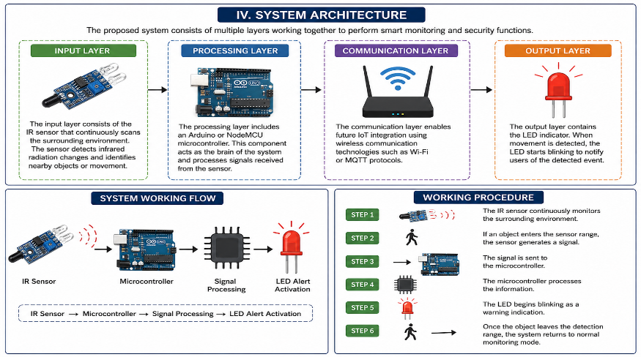

5. DEVELOPMENT PLAN

Development Methodology

The project follows the Agile development methodology because it allows incremental development and continuous testing.

Sprint 1: Requirement Analysis

- Understanding system requirements
- Identifying hardware components
- Defining project objectives

Sprint 2: Hardware Design

- Designing circuit connections
- Connecting IR sensors and LEDs
- Hardware verification

Sprint 3: Software Development

- Writing Arduino code
- Implementing sensor logic
- Programming LED response mechanisms

Sprint 4: Testing and Debugging

- Identifying software errors
- Correcting hardware issues
- Improving system performance

Sprint 5: Deployment and Documentation

- Final implementation
- Report preparation
- Demonstration of the project

6. TESTING AND QUALITY STRATEGY

Test Case | Expected Result | Status
Object detection test | Sensor detects object correctly | Pass
LED blinking test | LED blinks when object detected | Pass
Continuous monitoring | System monitors continuously | Pass
Response time test | Immediate response | Pass
Hardware stability | Stable operation | Pass

Acceptance Criteria

The project will satisfy quality standards if:

- The sensor accurately detects movement.

- The LED responds immediately.

- System performance remains stable.

- Continuous operation is maintained.

7. DEPLOYMENT AND OPERATIONS

The developed prototype is deployed using Arduino hardware, IR sensors, LEDs, and supporting electronic components. The system continuously performs monitoring tasks and provides immediate alert indications whenever movement is detected.

Future enhancements may include:

- Mobile application connectivity

- Alarm system integration

- Cloud monitoring

- Voice assistant integration

- Camera-based surveillance

8
8. RISK MANAGEMENT
Risk | Impact | Mitigation
Sensor malfunction | Incorrect detection | Regular maintenance
Hardware damage | System failure | Replace components
Power interruption | System shutdown | Use backup batteries
False detection | Incorrect alerts | Sensor calibration

9. CHANGE MANAGEMENT
Any modifications made to hardware components, sensor configurations, communication protocols, or

software logic should be properly documented and tested before implementation. Version control

practices should be maintained to ensure project stability and facilitate future improvements.

10. CONCLUSION

The IoT Nexus – Smart Home Automation and Security System successfully demonstrates the
implementation of IoT technology for improving home security and automation. The system uses an IR sensor to continuously monitor the surrounding environment and detect the presence of objects or movement. Whenever the sensor detects an object within its range, it sends a signal to the microcontroller, which processes the information and activates the LED blinking mechanism as a security alert.

The project provides an efficient, reliable, and cost-effective solution for basic smart home monitoring. It reduces the need for continuous manual supervision and offers an automated approach to detecting suspicious activities. The use of sensors and microcontrollers makes the system simple to implement while also providing opportunities for future expansion.

Furthermore, this project demonstrates how IoT-based systems can improve safety, convenience, and automation in residential environments. Future enhancements may include integration with mobile applications, cloud platforms, alarm systems, and camera-based surveillance for more advanced monitoring capabilities. Overall, the developed system achieves its intended objectives and highlights the practical applications of IoT in smart home security systems.

